**Object of dataset for object detection**

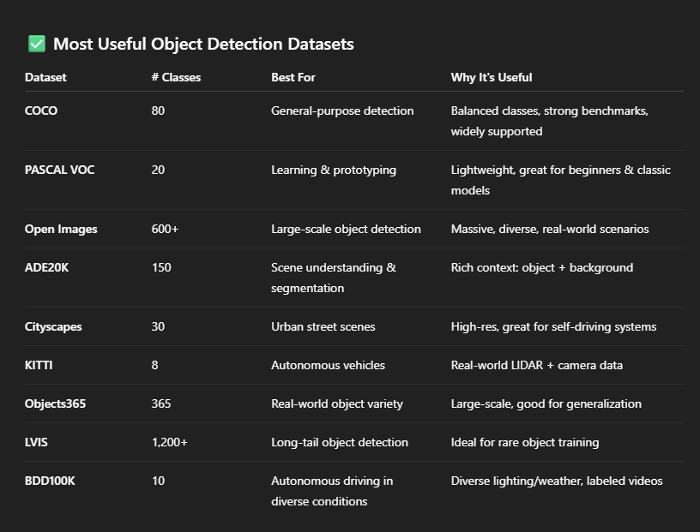

* **PASCAL VOC Object Classes (20):**

1. **Aeroplane** **12. bicycle**
2. **Bird 13.boat**
3. **Bottle 14.bus**
4. **Car 15.cat**
5. **Chair 16. cowdining table 17.dog**
6. **horse 18.motorbike**
7. **person 19.potted plant**
8. **sheep 20. sofa**
9. **train**
10. **tv monitor**

* **Cityscapes Classes (30):.**

1. **Road             16. Bus**
2. **Sidewalk           17. Train**
3. **Building            18. Motorcycle**
4. **Wall             19. Bicycle**
5. **Fence             20. Parking**
6. **Pole             21. Rail track**
7. **Traffic light          22. Guard rail**
8. **Traffic sign          23. Bridge**
9. **Vegetation          24. Tunnel**
10. **Terrain            25. Pole group**
11. **Sky              26. Dynamic**
12. **Person            27. Static**
13. **Rider             28. Ground**
14. **Car              29. Caravan**
15. **Truck             30. Trailer**

* **KITTI Object Classes(8)**

1. **Car**
2. **Van**
3. **Truck**
4. **Pedestrian**
5. **Person_sitting**
6. **Cyclist**
7. **Tram**
8. **Misc** *(e.g., trailer, construction vehicles)*

* **COCO Object Categories (80)**

1. **Person              41. Skis**
2. **Bicycle             42. Snowboard**
3. **Car               43. Sports ball**
4. **Motorcycle          44. Kite**
5. **Airplane             45. Baseball bat**
6. **Bus               46. Baseball glove**
7. **Train              47. Skateboard**
8. **Truck              48. Surfboard**
9. **Boat              49. Tennis racket**
10. **Traffic light         50. Bottle**
11. **Fire hydrant         51. Wine glass**
12. **Stop sign           52. Cup**
13. **Parking meter       53. Fork**
14. **Bench             54. Knife**
15. **Bird              55. Spoon**
16. **Cat               56. Bowl**
17. **Dog              57. Banana**
18. **Horse              58. Apple**
19. **Sheep             59. Sandwich**
20. **Cow              60. Orange**
21. **Elephant           61. Broccoli**
22. **Bear              62. Carrot**
23. **Zebra              63. Hot dog**
24. **Giraffe            64. Pizza**
25. **Backpack           65. Donut**
26. **Umbrella           66. Cake**
27. **Handbag          67. Chair**
28. **Tie               68. Couch**
29. **Suitcase           69. Potted plant**
30. **Frisbee             70. Bed**
31. **Skis              71. Dining table**
32. **Snowboard           72. Toilet**
33. **Sports ball          73. TV**
34. **Kite              74. Laptop**
35. **Baseball bat        75. Mouse**
36. **Baseball glove      76. Remote**
37. **Skateboard         77. Keyboard**
38. **Surfboard          78. Cell phone**
39. **Tennis racket       79. Microwave**
40. **Bottle             80. Oven**

* **BDD100K Object Classes (10):**

1. **Person          6. Bus**
2. **Rider           7. Truck**
3. **Car             8. Train**
4. **Bike            9. Motorcycle**
5. **Traffic light     10. Traffic sign**

* **ADE20K classes(150)**

**1. Wall 51. Sink 101. Oven**

**2. Building 52. Refrigerator 102. Stove**

**3. Sky 53. Doorframe 103. Sink (kitchen)**

**4. Floor 54. Blinds 104. Fridge**

**5. Tree 55. TV 105. Blender**

**6. Ceiling 56. Paper 106. Toaster**

**7. Road 57. Towel 107. Washing machine**

**8. Bed 58. Shower curtain 108. Dryer**

**9. Window 59. Package 109. Bathtub**

**10. Grass 60. Whiteboard 110. Toilet**

**11. Cabinet 61. Blanket 111. Bottle**

**12. Sidewalk 62. Pillow 112. Wine glass**

**13. Person 63. Screen 113. Cup**

**14. Earth 64. Blackboard 114. Plate**

**15. Door 65. Toilet paper 115. Spoon**

**16. Table 66. Tissue box 116. Bowl**

**17. Mountain 67. Soap 117. Banana**

**18. Plant 68. Bookcase 118. Apple**

**19. Curtain 69. Toolbox 119. Orange**

**20. Chair 70. Bucket 120. Sandwich**

**21. Car 71. Clock 121. Broccoli**

**22. Water 72. Wall mirror 122. Carrot**

**23. Painting 73. Fan 123. Hot dog**

**24. Sofa 74. Mug 124. Pizza**

**25. Shelf 75. Bag 125. Donut**

**26. House 76. Sand 126. Cake**

**27. Sea 77. Ceiling light 127. Office chair**

**28. Mirror 78. Awning 128. Laptop**

**29. Rug 79. Flag 129. Mouse**

**30. Field 80. Banner 130. Remote**

**31. Armchair 81. Countertop 131. Keyboard**

**32. Cushion 82. Floor mat 132. Cell phone**

**33. Statue 83. Railing 133. Microwave**

**34. Pier 84. Window casing 134. Oven (range)**

**35. Fence 85. Wall base 135. Toaster (duplicate)**

**36. Desk 86. Pillar 136. Bathtub (modern)**

**37. Rock 87. Signboard 137. Toilet seat**

**38. Bridge 88. Glass 138. Faucet**

**39. Book 89. Speaker 139. Radiator**

**40. Boat 90. Pendant light 140. Shower head**

**41. Tower 91. Vase 141. Soap bar**

**42. Bench 92. Power outlet 142. Treadmill**

**43. Carpet 93. Poster (duplicate) 143. Printer**

**44. Light 94. Mirror (duplicate) 144. Air conditioner**

**45. Poster 95. Fan (duplicate) 145. Trash can**

**46. Stairs 96. Fence (duplicate) 146. Water dispenser**

**47. Box 97. Clock (duplicate) 147. Bathroom mirror**

**48. Column 98. Sign (duplicate) 148. Paper towel**

**49. Sign 99. Counter (duplicate) 149. Hand dryer**

**50. Counter 100. Light (duplicate) 150. Glass door**

* **Open Images(601)**

**1. Person 201. Crab 401. Parrot**

**2. Man 202. Lobster 402. Bald eagle**

**3. Woman 203. Shrimp 403. Pelican**

**4. Boy 204. Squid 404. Flamingo**

**5. Girl 205. Octopus 405. Swan**

**6. Human face 206. House 406. Peacock**

**7. Human arm 207. Building 407. Seagull**

**8. Human nose 208. Skyscraper 408. Pigeon**

**9. Human eye 209. Bridge 409. Cuckoo**

**10. Human ear 210. Tower 410. Woodpecker**

**11. Human mouth 211. Windmill 411. Crow**

**12. Human foot 212. Lighthouse 412. Duck**

**13. Human hand 213. Castle 413. Goose**

**14. Vehicle 214. Tent 414. Turkey**

**15. Car 215. Stadium 415. Chicken**

**16. Bus 216. Barn 416. Rooster**

**17. Truck 217. Fountain 417. Owl**

**18. Bicycle 218. Bench 418. Eagle**

**19. Motorcycle 219. Chair 419. Hawk**

**20. Airplane 220. Sofa 420. Falcon**

**21. Boat 221. Bed 421. Vulture**

**22. Ship 222. Table 422. Bat**

**23. Train 223. Desk 423. Chameleon**

**24. Helicopter 224. Cabinet 424. Iguana**

**25. Traffic light 225. Shelf 425. Gecko**

**26. Traffic sign 226. Mirror 426. Alligator**

**27. Street light 227. Sink 427. Crocodile**

**28. Fire hydrant 228. Toilet 428. Lizard**

**29. Dog 229. Bathtub 429. Tortoise**

**30. Cat 230. Shower 430. Snake**

**31. Horse 231. Refrigerator 431. Cobra**

**32. Cow 232. Microwave oven 432. Viper**

**33. Sheep 233. Oven 433. Rattlesnake**

**34. Elephant 234. Toaster 434. Python (snake)**

**35. Zebra 235. Blender 435. Boa constrictor**

**36. Giraffe 236. Coffee machine 436. Turtle**

**37. Bear 237. Television 437. Sea turtle**

**38. Bird 238. Laptop 438. Jellyfish**

**39. Duck 239. Computer monitor 439. Coral**

**40. Chicken 240. Keyboard 440. Seaweed**

**... (continues up to 601)**

* **Objects365 classes (365 )**

**1. person 122. hamster 243. soccer**

**2. bicycle 123. tiger 244. baseball glove**

**3. car 124. lion 245. skateboard**

**4. motorcycle 125. cow 246. surfboard**

**5. airplane 126. elephant 247. tennis racket**

**6. bus 127. bear 248. bottle**

**7. train 128. zebra 249. wine glass**

**8. truck 129. giraffe 250. cup**

**9. boat 130. backpack 251. fork**

**10. traffic light 131. umbrella 252. knife**

**11. fire hydrant 132. handbag 253. spoon**

**12. stop sign 133. tie 254. bowl**

**13. parking meter 134. suitcase 255. banana**

**14. bench 135. frisbee 256. apple**

**15. bird 136. skis 257. sandwich**

**16. cat 137. snowboard 258. orange**

**17. dog 138. sports ball 259. broccoli**

**18. horse 139. kite 260. carrot**

**19. sheep 140. baseball bat 261. hot dog**

**20. couch 141. baseball glove 262. pizza**

**21. potted plant 142. skateboard 263. donut**

**22. bed 143. surfboard 264. cake**

**23. dining table 144. tennis racket 265. chair**

**24. toilet 145. bottle 266. couch (again)**

**25. tv 146. wine glass 267. potted plant (again)**

**26. laptop 147. cup 268. bed (again)**

**27. mouse 148. fork 269. dining table (again)**

**28. remote 149. knife 270. toilet (again)**

**29. keyboard 150. spoon 271. tv (again)**

**30. cell phone 151. bowl 272. laptop (again)**

**31. microwave 152. banana 273. mouse (again)**

**32. oven 153. apple 274. remote (again)**

**33. toaster 154. sandwich 275. keyboard (again)**

**34. sink 155. orange 276. cell phone (again)**

**35. refrigerator 156. broccoli 277. microwave (again)**

**36. book 157. carrot 278. oven (again)**

**37. clock 158. hot dog 279. toaster (again)**

**38. vase 159. pizza 280. sink (again)**

**39. scissors 160. donut 281. refrigerator (again)**

**40. teddy bear 161. cake 282. book (again)**

**41. hair drier 162. chair 283. clock (again)**

**42. toothbrush 163. couch (yet again) 284. vase (again)**

**43. frisbee 164. potted plant (yet again) 285. scissors (again)**

**44. skis 165. bed (yet again) 286. teddy bear (again)**

**45. snowboard 166. dining table (yet again) 287. hair drier (again)**

**46. sports ball 167. toilet (yet again) 288. toothbrush (again)**

**47. kite 168. tv (yet again) 289. frisbee (again)**

**48. baseball bat 169. laptop (yet again) 290. skis (again)**

**49. skateboard 170. mouse (yet again) 291. snowboard (again)**

**50. surfboard 171. remote (yet again) 292. sports ball (again)**

**... (continues to 365)**

**LVIS (Large Vocabulary Instance Segmentation) (1230)**

**1. person 411. jug 821. coin**

**2. bicycle 412. kettle 822. tape dispenser**

**3. car 413. pitcher 823. mailbox**

**4. motorcycle 414. teapot 824. stethoscope**

**5. airplane 415. rice cooker 825. barbell**

**6. bus 416. blender 826. pencil case**

**7. train 417. popcorn machine 827. dice**

**8. truck 418. cooler 828. abacus**

**9. boat 419. water cooler 829. dartboard**

**10. traffic light 420. barrel 830. wheelchair**

**11. fire hydrant 421. crate 831. podium**

**12. stop sign 422. trunk 832. trophy**

**13. parking meter 423. basket 833. frisbee**

**14. bench 424. suitcase 834. kite**

**15. bird 425. backpack 835. yo-yo**

**16. cat 426. handbag 836. hula hoop**

**17. dog 427. purse 837. skipping rope**

**18. horse 428. wallet 838. accordion**

**19. sheep 429. briefcase 839. harmonica**

**20. couch 430. laptop bag 840. drum**

**21. potted plant 431. shopping bag 841. tambourine**

**22. bed 432. paper bag 842. xylophone**

**23. dining table 433. plastic bag 843. violin**

**24. toilet 434. gift bag 844. guitar**

**25. tv 435. jewelry box 845. saxophone**

**26. laptop 436. toolbox 846. trumpet**

**27. mouse 437. lunch box 847. clarinet**

**28. remote 438. pencil box 848. flute**

**29. keyboard 439. tissue box 849. banjo**

**30. cell phone 440. soap box 850. harp**

**... (continues up to 1230)**